Rate Limiter
A rate limiter limits the number of client requests allowed to be sent over a specified period. If the API
request count exceeds the threshold defined by the rate limiter, all the excess calls are blocked, and you will get 429 Too Many Requests error. Here are
a few examples:
• A user can write no more than 2 posts per second.
• You can create a maximum of 10 accounts per day from the same IP address.

Benefits of using an API rate limiter:
1)Prevent resource starvation caused by Denial of Service (DoS) attack. Almost all APIs published by large
tech companies enforce some form of rate limiting. For example, Twitter limits the number of tweets to
300 per 3 hours.
2)Reduce cost. Limiting excess requests means fewer servers and allocating more resources to high
priority APIs.
3)Prevent servers from being overloaded. To reduce server load, a rate limiter is used to filter out excess
requests caused by bots or users’ misbehaviour.

Functional Requirements
These define what the system must do.
Core behaviours:
- Allow or deny requests — for every incoming request, the system must decide in real time whether to allow it or return a 429 Too Many Requests response.
- Per-client limiting — limits must be enforced independently per client, identified by API key, user ID, or IP address.
- Configurable rules — different clients or endpoints can have different limits. Example: free tier gets 100 req/min, premium gets 1000 req/min.
- Multiple algorithms — system should support token bucket, sliding window, or fixed window depending on use case.
- Response headers — every response must include rate limit metadata so the client knows its current status.
  - X-RateLimit-Limit — total quota
  - X-RateLimit-Remaining — requests left
  - X-RateLimit-Retry-After — seconds until reset
- Rule management — ability to add, update, or delete rate limit rules without restarting the system.
- Whitelist / Blacklist — certain clients (internal services, admin keys) can be permanently allowed or blocked regardless of limits.

Non-Functional Requirements
These define how well the system must do it.
1. Low latency The rate limiter sits in the critical path of every API request. It must make its allow/deny decision in under 5 milliseconds. Any slower and it becomes the bottleneck itself.
2. High availability The rate limiter must never be a single point of failure. If it goes down, the system must either fail open (allow all requests) or fail closed (deny all) — and that policy must be a conscious design choice.
3. Scalability Must handle millions of requests per second across thousands of clients without degrading. Horizontally scalable — adding more nodes should linearly increase capacity.
4. Accuracy Counters across distributed nodes must be consistent enough that a client cannot bypass limits by hitting different servers. Small inconsistency is acceptable but systematic bypass is not.
5. Fault tolerance If the backing store (Redis) becomes unavailable, the system must have a fallback strategy — either in-memory local limiting or fail open — with automatic recovery when the store comes back.
6. Durability Rate limit counters should survive short outages. A client should not be able to reset their limit by triggering a server restart.
7. Observability The system must emit metrics — total requests, throttled requests, throttle rate per client — so engineers can monitor abuse and tune limits.
8. Thread safety Counter reads and writes must be atomic. On a single server, concurrent requests for the same client must not cause race conditions that allow more requests than the limit.

In all rate limiting algorithms, the counter or state is always per user (or per IP, or per API key — depending on how you configure it).

API Gateway is the primary place for rate limiting. It is the single-entry point, so you can enforce limits globally before requests even reach your services. This protects all services at once without any code in individual services.

Individual services add rate limiting only for specific sensitive endpoints that need extra protection — like login (prevent brute force), password reset (prevent abuse), or money transfers (prevent fraud).

Algorithm 1 — Fixed Window
How it works: Fixed window counter algorithm works as follows:
• The algorithm divides the timeline into fix-sized time windows and assign a counter for
each window.
• Each request increments the counter by one.
• Once the counter reaches the pre-defined threshold, new requests are dropped until a new
time window starts. Reset counter at the start of each new window.
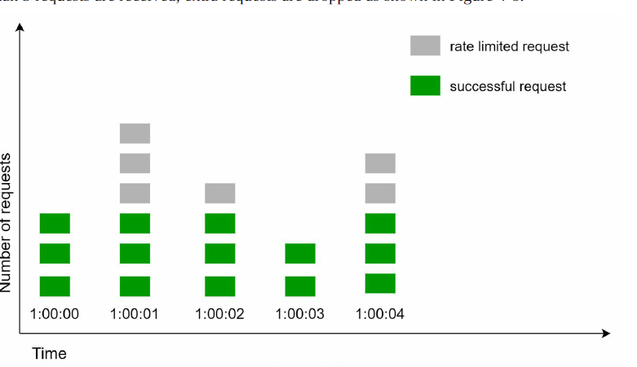
Problem: A client can exploit the window boundary — send max requests at the end of one window and max requests at the start of the next, effectively doubling the limit in a short burst.
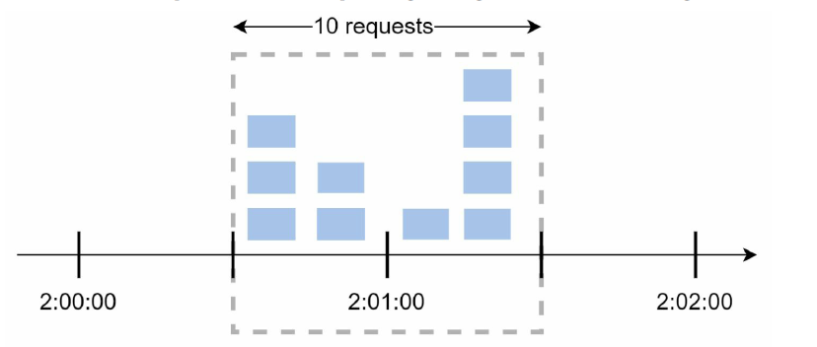

Algorithm 2 — Sliding Window
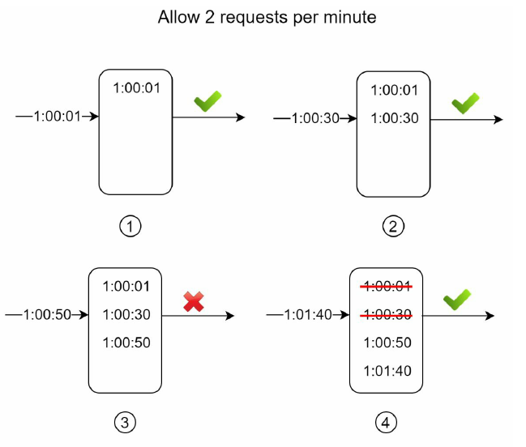
Here we maintain log of timestamps. The timestamps are added to the log. When a new request comes in, remove all the outdated timestamps. Outdated timestamps
are defined as those older than the start of the current time window. If the log size is the same or lower than the allowed count, a request is accepted.
Otherwise, it is rejected.
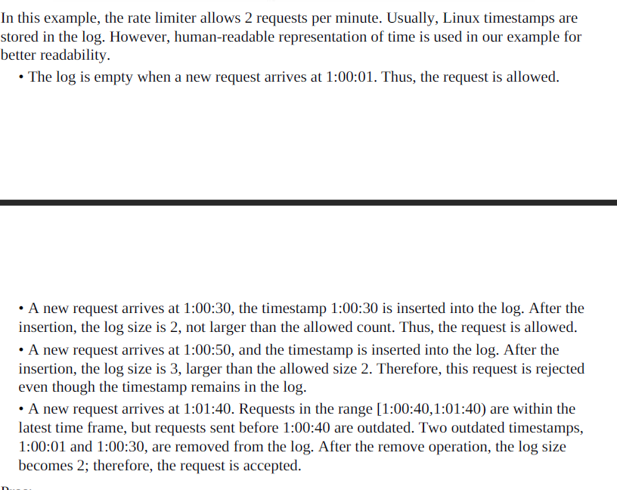
Cons:
• The algorithm consumes a lot of memory because even if a request is rejected, its
timestamp might still be stored in memory.

Algorithm 3 — Token Bucket
This algorithm is widely used by the internet companies. Amazon and stripe use this.
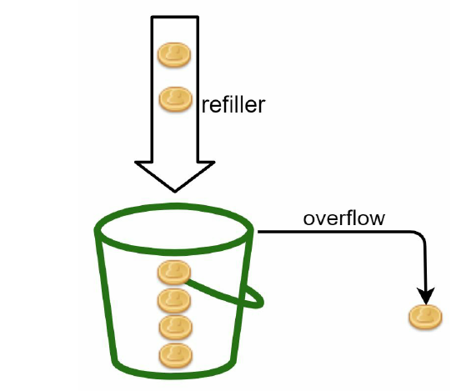
How it works: A token bucket is a container with pre-defined capacity. Tokens are added at a fixed rate (e.g. 2 per second). Each request consumes one token. If the bucket has tokens — allow the request. If empty — reject with 429. If the user has been idle, tokens accumulate, allowing short bursts of traffic.

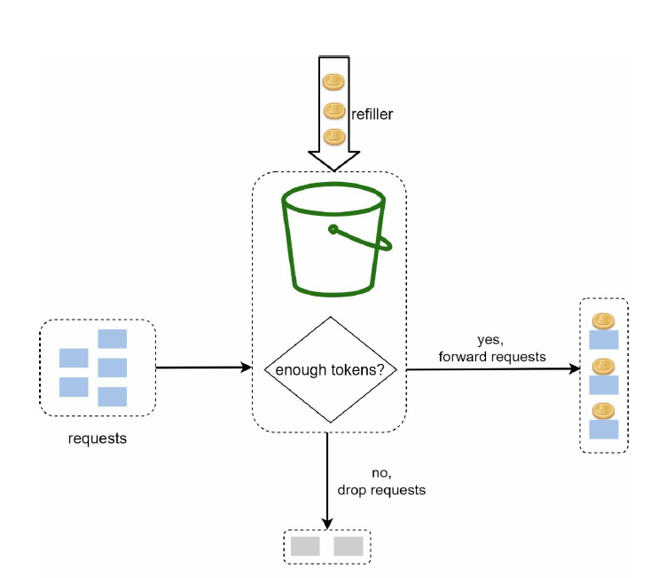
The token bucket takes two parameters:
a)Bucket Size
b)Refill Rate
How many buckets do we need? It is usually required to have different buckets for different API end points.
Pros:
• The algorithm is easy to implement.
• Memory efficient.
• Token bucket allows a burst of traffic for short periods. . A user who has been quiet for 5 seconds has saved up tokens and can fire multiple requests quickly.

Cons:
• Two parameters in the algorithm are bucket size and token refill rate. However, it might
be challenging to tune them properly.

Algorithm 4 — Leaky Bucket
How it works: The leaking bucket algorithm is like the token bucket except that requests are processed at a fixed rate. It is usually implemented with a first-in-first-out (FIFO) queue.The queue processes them at a fixed output rate regardless of how fast they come in. The algorithm works as follows:
• When a request arrives, the system checks if the queue is full. If it is not full, the request
is added to the queue.
• Otherwise, the request is dropped.
• Requests are pulled from the queue and processed at regular intervals.
Difference from Token Bucket: Token bucket lets accumulated tokens be spent in a burst — 10 requests can fire instantly if tokens are available. Leaky bucket never allows bursts — output is always the same fixed rate no matter what.
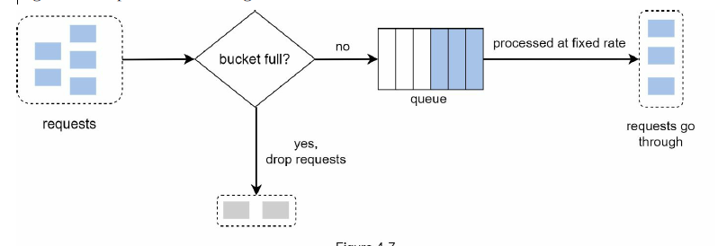
It takes two parameters:
a)Bucket Size
b)Outflow Rate: How many requests can be processed at fixed rate.
Pros:
• Memory efficient given the limited queue size.
• Requests are processed at a fixed rate therefore it is suitable for use cases that a stable
outflow rate is needed.

Cons:
• There are two parameters in the algorithm. It might not be easy to tune them properly.

Algorithm Selection
Fixed Window — Rejected The boundary burst exploit is a fundamental flaw, not an edge case. A client can systematically double their effective limit every minute. Unacceptable for a production rate limiter.
Sliding Window Log — Rejected Accuracy is perfect but memory cost is proportional to request volume. At 10M clients each firing 1000 req/min, storing individual timestamps becomes gigabytes of data in Redis. Does not scale.
Leaky Bucket — Rejected Perfectly smooth output sounds good but it penalises legitimate bursty clients. A mobile app that fires 5 requests on page load gets queued and delayed even though the server can handle it fine. Too strict for an API rate limiter — better suited for network traffic shaping.
Token Bucket — Selected Handles bursts fairly, stores only 3 values per client, single atomic Redis operation per request, and is the proven choice at AWS, Stripe, and Shopify.

High-level architecture
At the high-level, we need a counter to keep track of how many requests are sent from the same user, IP address, etc. If the counter is larger than the limit, the request is disallowed. Where shall we store counters? Using the database is not a good idea due to slowness of disk access. In-memory cache is chosen because it is fast and supports time-based expiration strategy. For instance, Redis is a popular option to implement rate limiting. It is an in-memory store that offers two commands: INCR and EXPIRE.
• INCR: It increases the stored counter by 1.
• EXPIRE: It sets a timeout for the counter. If the timeout expires, the counter is automatically deleted.
Why Redis specifically — not a database?
Simple answer: speed.
A database reads and writes from disk. Redis is a distributed cache, reads and writes from RAM. RAM is roughly 100x faster than disk. Since the rate limiter runs on every single API request, it must be extremely fast — otherwise it slows down your entire API. Redis gives us that speed while still being shared across all servers.
While designing high level architecture two more questions come into picture
- How are rate limiting rules created? Where are the rules stored?
- How to handle requests that are rate limited?
The rate limiting rules usually have to contain 5 core components and they are written in configuration files and they are stored on disks.
Key / Identifier: What is being limited (e.g., User ID, IP address, API Endpoint, or API Token).
Capacity (Bucket Size): The maximum number of requests allowed in a sudden burst.
Refill Rate: How many tokens or requests are added back over a specific time window (e.g., 5 tokens per second).
Window Size: The timeframe used for calculation (e.g., per second, per minute, per day).
Action: What happens when the limit is breached
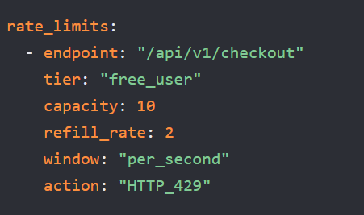

In case a request is rate limited; APIs return a HTTP response code 429 (too many requests) to the client. Depending on the use cases, we may enqueue the rate-limited requests to be processed later. For example, if some orders are rate limited due to system overload, we may keep those orders to be processed later.
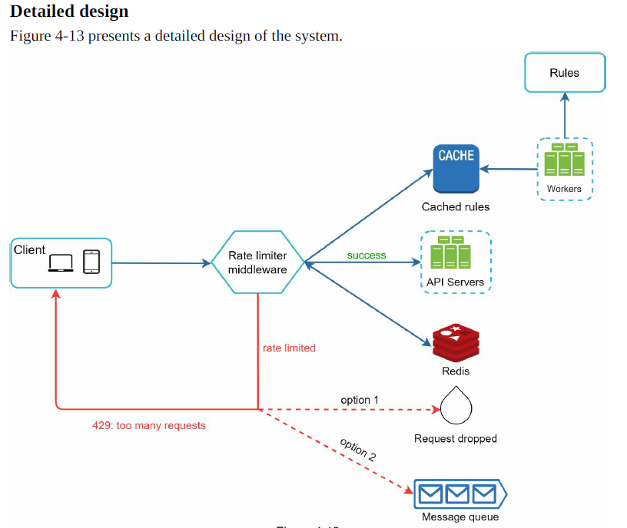

- Rules are stored on the disk. Workers frequently pull rules from the disk and store them in the cache.
- When a client sends a request to the server, the request is sent to the rate limiter
- middleware first.
- Rate limiter middleware loads rules from the cache. It fetches counters and last request timestamp from Redis cache. Based on the response, the rate limiter decides:
- if the request is not rate limited, it is forwarded to API servers.
- if the request is rate limited, the rate limiter returns 429 too many requests error to
- the client. In the meantime, the request is either dropped or forwarded to the queue

Storage Design
When a request comes in, we need to check — has this client exceeded their limit?
Where do we remember things about the client, and what exactly do we remember?
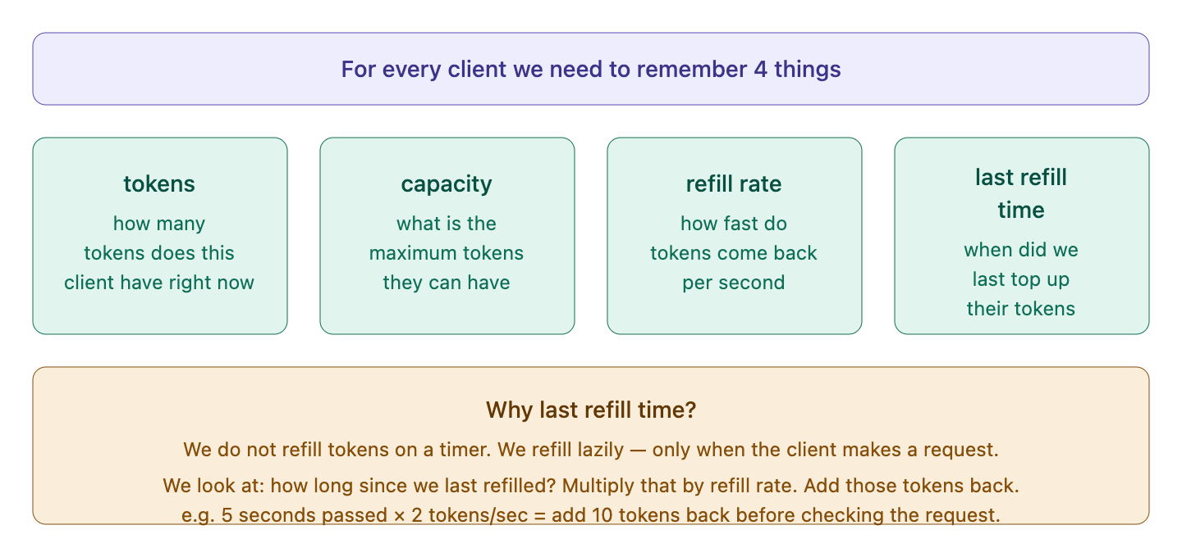
Where do we store these 4 values?
We need a place that all our servers can read and write. Think of it like a shared notebook that every server can open.
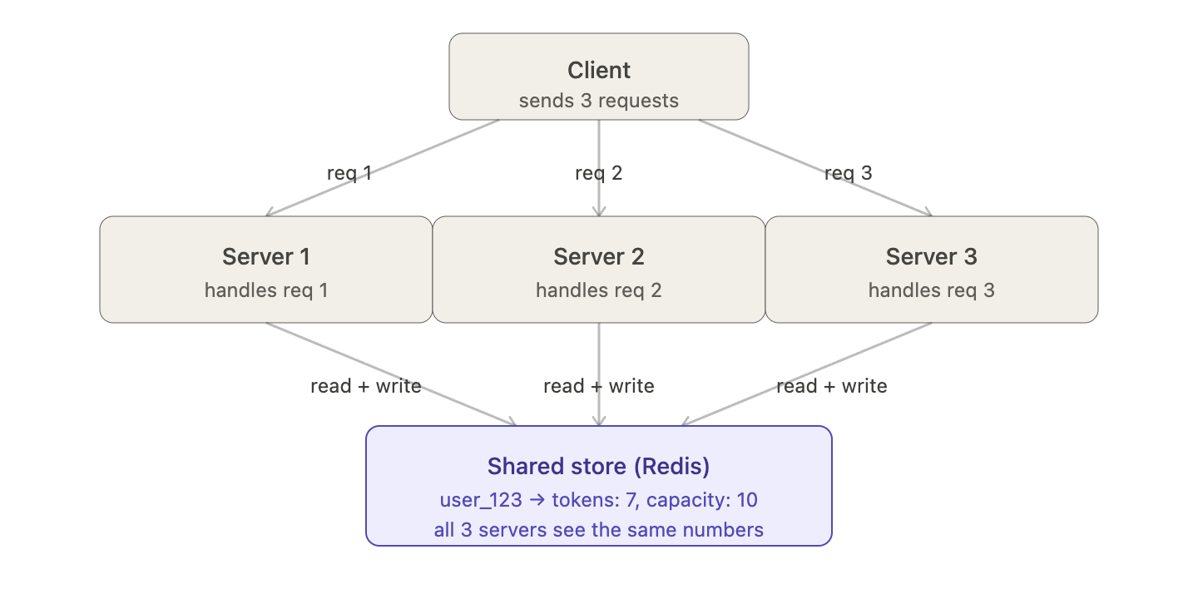

How the data actually looks in Redis
Think of Redis like a dictionary. The key is who the client is. The value is a small record with those 4 fields.
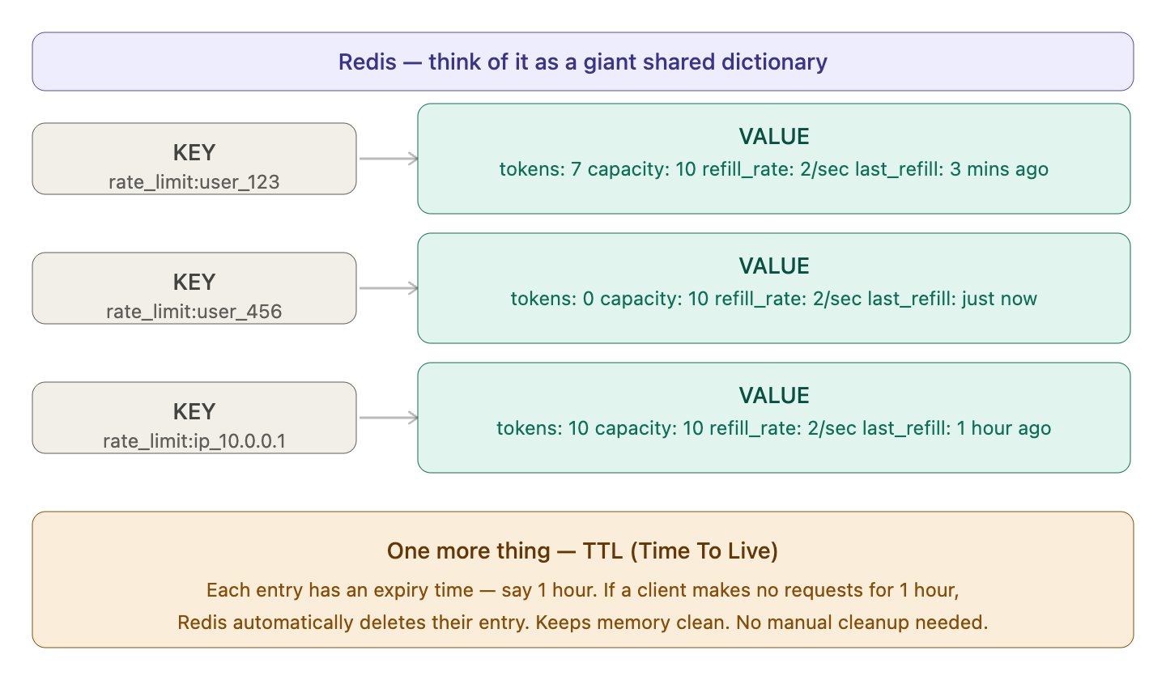

Rate Limiter in Distributed Design
It faces two challenges
- Race Condition
- Synchronization issue

As discussed earlier, rate limiter works as follows at the high-level:
• Read the counter value from Redis.
• Check if ( counter + 1 ) exceeds the threshold.
• If not, increment the counter value by 1 in Redis.
Race conditions can happen in a highly concurrent environment as shown in Figure 4-14.

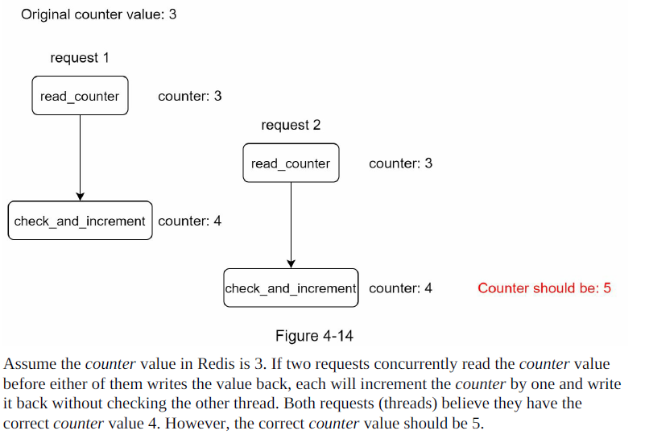

The solution — Lua Script in Redis
The fix is to make read + decide + write happen as one single atomic operation. No other server can jump in between.
Redis has a feature called Lua scripting. You send a small script to Redis and Redis executes all of it in one shot — nothing else can run in Redis while your script is running.
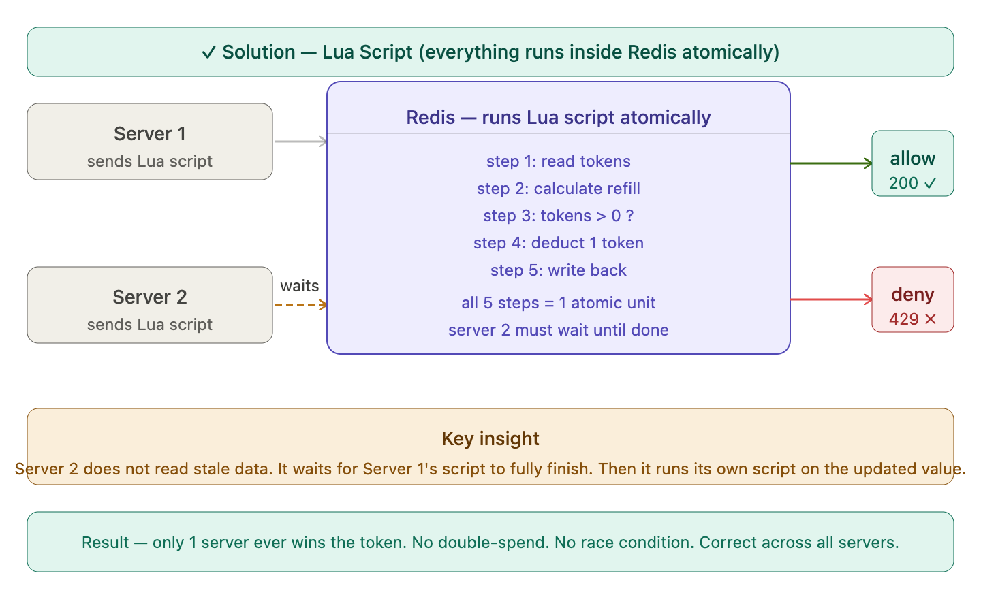

Synchronization Issue
When multiple users are there one rate limiter doesn’t help out. We need multiple rate limiters and hence need for synchronization arrives.

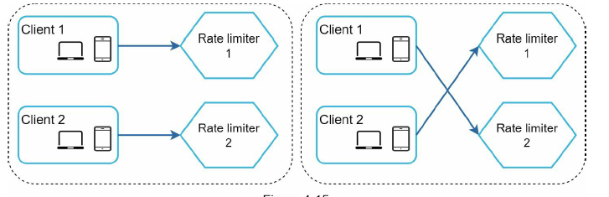

Here suppose we have two clients and two different rate limiters for each service so when they hit the request, they get the data from the individual caches but if client1 tries to hit the rate limiter2 no data will be present because there is no synchronization. So we can add a redis cache which acts as a common cache to solve this problem.

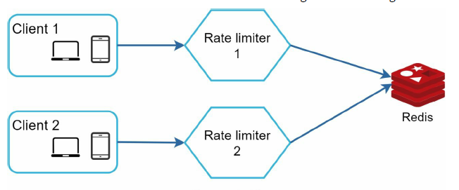

Failure Handling
What happens if Redis goes down?
Redis is now in the critical path of every request. If it becomes unavailable, we have a choice to make.
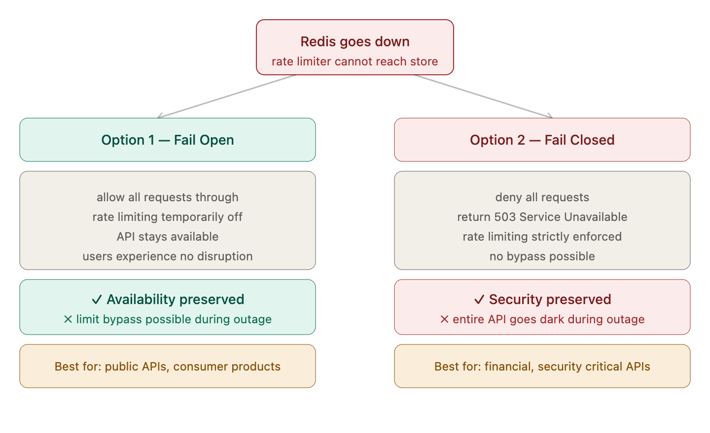
The better approach — Local fallback
Instead of choosing between fail open or fail closed completely, a smarter strategy is to fall back to local in-memory limiting on each server.
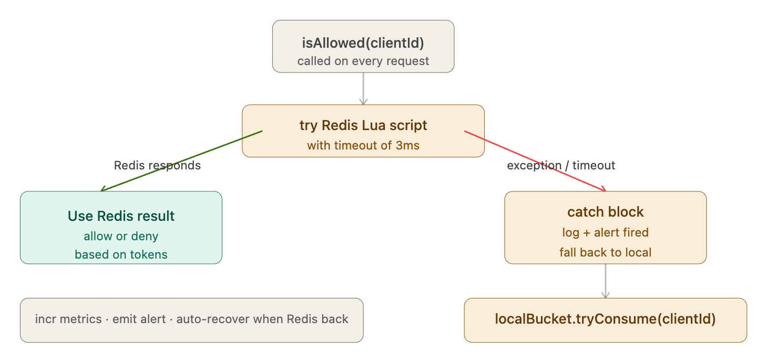

LLD

1. Pom.XML

<!-- Jedis -- Java Redis client -->
<dependency>
<groupId>redis.clients</groupId>
<artifactId>jedis</artifactId>
<version>5.1.0</version>
</dependency>

2. Controller

@RestController
public class ApiController {
// Public endpoint -- anyone can call (still rate limited)
@GetMapping("/api/data")
public String getData() {
return "{ \"message\": \"Here is your data\" }";
}
// Premium endpoint -- rate limited with higher quota
@GetMapping("/api/premium/data")
public String getPremiumData() {
return "{ \"message\": \"Here is your premium data\" }";
}
}

3. RateLimiter

@Component // Spring will create one instance and share it everywhere
public class RateLimiter {
// Lua script -- atomically: read → refill → consume → write
private static final String LUA_SCRIPT =
"local tokens = tonumber(redis.call('HGET', KEYS[1], 'tokens')) " +
"local lastRefill = tonumber(redis.call('HGET', KEYS[1], 'last_refill')) " +
"local capacity = tonumber(ARGV[1]) " +
"local refillRate = tonumber(ARGV[2]) " +
"local now = tonumber(ARGV[3]) " +
"if tokens == nil then tokens = capacity lastRefill = now end " +
"local elapsed = (now - lastRefill) / 1000 " +
"tokens = math.min(capacity, tokens + elapsed * refillRate) " +
"local allowed = 0 " +
"if tokens >= 1 then tokens = tokens - 1 allowed = 1 end " +
"redis.call('HSET', KEYS[1], 'tokens', tokens, 'last_refill', now) " +
"redis.call('EXPIRE', KEYS[1], 3600) " +
"return {allowed, math.floor(tokens)}";
private final JedisPool jedisPool;
// Local fallback when Redis is down
private final Map<String, double[]> localBuckets = new ConcurrentHashMap<>();
public RateLimiter() {
// Reads host/port from application.properties
this.jedisPool = new JedisPool("localhost", 6379);
}
// capacity = max tokens (10 = free, 100 = premium)
// refillRate = tokens/sec (0.16 = free, 1.6 = premium)
public Map<String, String> handle(String apiKey, int capacity, double refillRate) {
boolean allowed;
int remaining;
try {
try (Jedis jedis = jedisPool.getResource()) {
List<Long> result = (List<Long>) jedis.eval(
LUA_SCRIPT, 1,
"rate_limit:" + apiKey,
String.valueOf(capacity),
String.valueOf(refillRate),
String.valueOf(System.currentTimeMillis())
);
allowed = result.get(0) == 1;
remaining = result.get(1).intValue();
}
} catch (Exception e) {
// Redis down -- local fallback
System.err.println("[RateLimiter] Redis down, using local fallback");
double[] bucket = localBuckets.computeIfAbsent(
apiKey, id -> new double[]{ capacity, System.currentTimeMillis() }
);
long now = System.currentTimeMillis();
double elapsed = (now - bucket[1]) / 1000.0;
bucket[0] = Math.min(capacity, bucket[0] + elapsed * refillRate);
bucket[1] = now;
allowed = bucket[0] >= 1;
if (allowed) bucket[0] -= 1;
remaining = (int) Math.floor(bucket[0]);
}
Map<String, String> headers = new HashMap<>();
headers.put("X-RateLimit-Limit", String.valueOf(capacity));
headers.put("X-RateLimit-Remaining", String.valueOf(remaining));
headers.put("X-RateLimit-Allowed", String.valueOf(allowed));
headers.put("X-RateLimit-Retry-After", allowed ? "0" :
String.valueOf((long)(1.0 / refillRate)));
return headers;
}
}

4. RateLimiterFilter

@Component // Spring automatically registers this as a filter for all requests
public class RateLimiterFilter extends OncePerRequestFilter {
// FREE tier config
private static final int FREE_CAPACITY = 10;
private static final double FREE_REFILL_RATE = 0.16; // ~10/min
// PREMIUM tier config
private static final int PREM_CAPACITY = 100;
private static final double PREM_REFILL_RATE = 1.6; // ~100/min
private final RateLimiter rateLimiter;
public RateLimiterFilter(RateLimiter rateLimiter) {
this.rateLimiter = rateLimiter;
}
@Override
protected void doFilterInternal(HttpServletRequest request,
HttpServletResponse response,
FilterChain chain)
throws ServletException, IOException {
// Step 1 -- read API key from request header
String apiKey = request.getHeader("X-API-Key");
// Step 2 -- no API key = reject immediately
if (apiKey == null || apiKey.isBlank()) {
response.setStatus(401);
response.getWriter().write("Missing X-API-Key header");
return;
}
// Step 3 -- determine tier from header (default FREE)
// In production this would come from a database lookup
String tier = request.getHeader("X-Tier");
boolean isPremium = "PREMIUM".equalsIgnoreCase(tier);
int capacity = isPremium ? PREM_CAPACITY : FREE_CAPACITY;
double refillRate = isPremium ? PREM_REFILL_RATE : FREE_REFILL_RATE;
// Step 4 -- check rate limit
Map<String, String> headers = rateLimiter.handle(apiKey, capacity, refillRate);
// Step 5 -- attach rate limit headers to every response
headers.forEach(response::setHeader);
// Step 6 -- allow or reject
boolean allowed = Boolean.parseBoolean(headers.get("X-RateLimit-Allowed"));
if (!allowed) {
// Stop here -- never reaches the controller
response.setStatus(429);
response.setContentType("application/json");
response.getWriter().write(
"{ \"error\": \"Rate limit exceeded\", " +
"\"retry_after\": " + headers.get("X-RateLimit-Retry-After") + " }"
);
return;
}
// Step 7 -- allowed, pass to the actual API controller
chain.doFilter(request, response);
}
}
How to run

bash

# 1. Start Redis
docker run -d -p 6379:6379 redis

# 2. Run the Spring Boot app
mvn spring-boot:run

How to test with curl
FREE tier — hits limit at 10:
bash
curl http://localhost:8080/api/data \
-H "X-API-Key: free-user-123" \
-H "X-Tier: FREE"

PREMIUM tier — limit is 100:
bash
curl http://localhost:8080/api/premium/data \
-H "X-API-Key: premium-user-xyz" \
-H "X-Tier: PREMIUM"

What you see in response headers:
X-RateLimit-Limit: 10
X-RateLimit-Remaining: 9
X-RateLimit-Retry-After: 0

When limit is exceeded — 429:
json
{ "error": "Rate limit exceeded", "retry_after": 6 }

